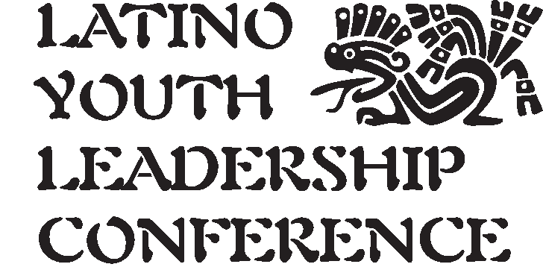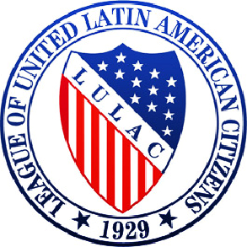

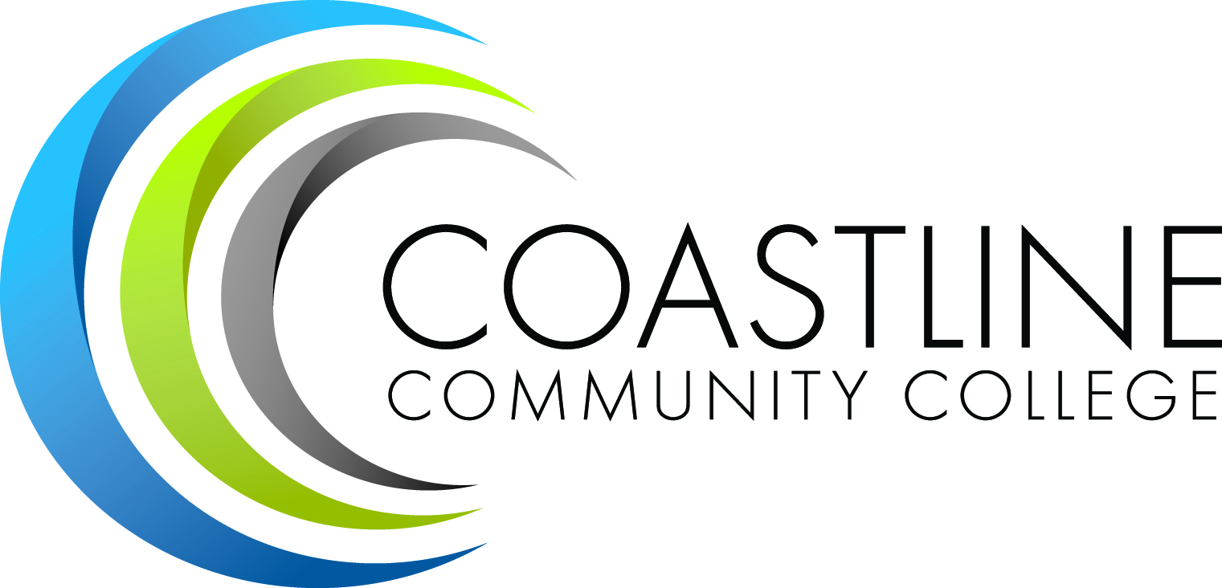

COASTLINE COMMUNITY COLLEGE/LEAGUE OF UNITED LATIN AMERICAN CITIZENS
Sixth Annual Latino Youth Leadership Development Conference

“Today’s Dreams, Tomorrow’s Realities”

Coastline Community College
Le-Jao Center, Westminster, California

Friday, March 2, 2012

Agenda

8:30 a.m. – 9:00 a.m. Registration

9:00 a.m. – 9:15 a.m. Welcome & Introductions

9:00 a.m. – 9:30 a.m. Welcome from Dr. Loretta Adrian
(Coastline) & Mr. Benny Diaz (LULAC)
Introduction of Dignitaries

9:30 a.m. – 10:00 a.m. Alex Nogales, Keynote Speaker
President and CEO
National Hispanic Media Coalition

10:00 a.m. – 10:15 a.m. Break

10:15 a.m. – 11:15 a.m. Workshop Session I

11:15 a.m. – 12:15 p.m. Workshop Session II

(Note: Sessions will alternate each hour)

12:15 p.m. – 1:00 p.m. Lunch (Provided)

1:00 p.m. – 1:30 p.m. Jennifer De La Rosa, Keynote Speaker

1:30 p.m. – 2:45 p.m. Dance Presentation – Jordi Cabellero & Jose Costas

Discussion and Youth Feedback

2:45 p.m. – 2:55 p.m. Conference Evaluation and Closing Remarks

“The future belongs to those who believe in
the beauty of their dreams.”
Eleanor Roosevelt
Latino Youth Leadership Conference
Workshop Sessions (From left to right on your name badge)

Session A Leadership and Public Service (Room 200)

Presenter: Lieutenant Timothy Vu (Westminster Police Department)

The presenter will discuss his unique journey to a leadership position in the Westminster Police Department. He will discuss how youths should pursue their dreams no matter the obstacle. He will also share how he is enriched by serving the community on a daily basis.

Session B Media: Art, Music and Culture (Room 202)

Presenters: Isaiah Aguirre (Coastline), Antonio Baiz (UCSD Student) and Dr. Richard Baiz (Professional Expert)

The presenters will discuss how Latina/o art, music and culture have influenced mainstream society. The presentation will include discussions of Latina/os in the media, how they have influenced their respective fields and what the future holds as media becomes more accessible in diverse forums.

Session C Entrepreneurship: Starting Your Own Business (Room 207)

Presenter: Paul Amador (CalArg)

The world of entrepreneurship requires creativity, innovation, dedication and discipline. Seven out of ten high school students in Orange County indicate they want to be business owners after graduation. This workshop will discuss ways you can pursue your aspirations of entrepreneurship and the steps needed to obtain your goal.

Session D College Opportunities (Room 211)

Presenters: Cristina Arellano, Marcela Hernandez and Anita Preciado (Coastline)

The presenters will engage students in topics that include how to begin the college application process, career and academic planning, student services for low income and minority students, and the steps required to enroll in school and persist through the obstacles many Latina/o students encounter. Workshop participants will also learn how to get involved on campus with Associated Student Government and clubs.

Session E League of United Latin American Citizens (LULAC): A Historical Perspective (Room 212)

Presenters: Benny Diaz and Angelina Madrid (LULAC)

The presenters will discuss the origins of LULAC; its mission and how the organization addresses issues of social change and education that bring about improvements in the Latino community.

Session F Volunteering and Internships (Room 214)

Presenters: Santana Ruiz (UCI)
Do you think volunteering and internships are a waste of time? The presenters will discuss the value of volunteerism and internships, and how participating in both can prove enriching for one’s personal development and are important to include on employment and college applications.

